Ryan Marinelli

Question 2

This plot is of the total amount of registered voters per parish. Parish is important to note since, it based on older French systems. It is a rather unique feature of geography in New Orleans.

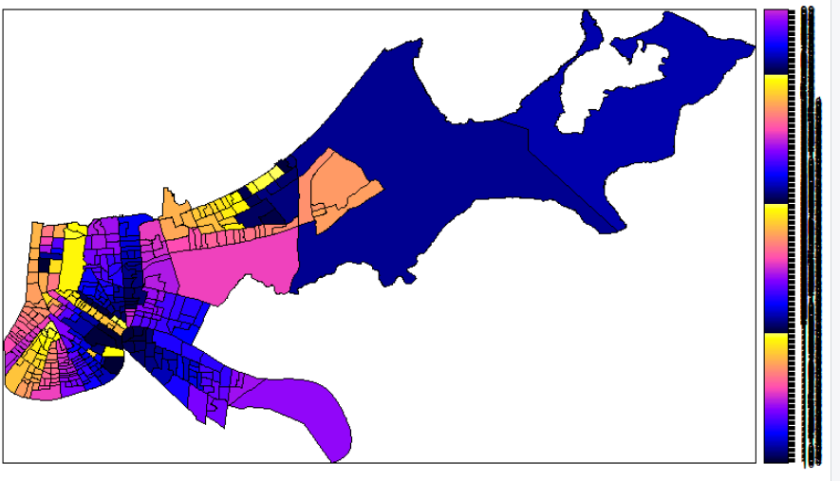

Question 3

The p-value is greater than .05, thus you fail to reject the null

The distribution of feature values could be the result of randomness

While this is difficult to accept in a qualitative sense, it could be that since

people are displaced so often because of flooding; it makes the process more random.

It could make it so that there is a less significant relationship between voting populations

and geography. But, this is only a suggestion.

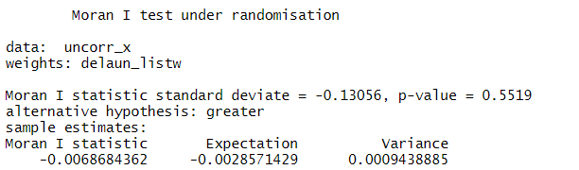

Question 4

The plot seems to reinforce the moran test. There are no clear clusters appearing in the data.

It appears that the values are slightly more negative though than positive.

